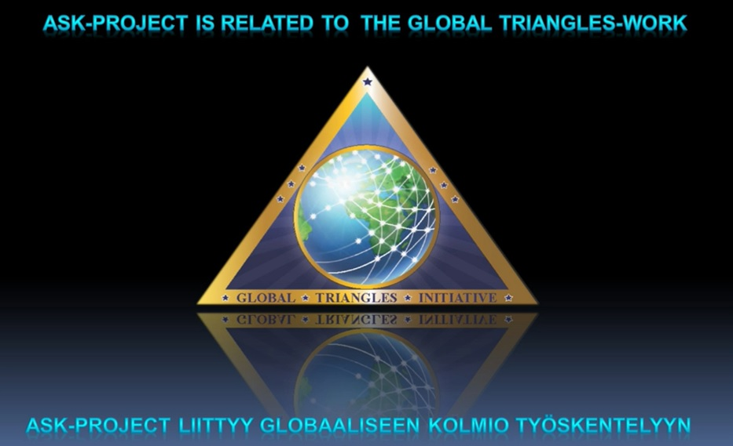

A.S.K-PROJECT Triangles Broadcast Events

Presented by Michael and Tuija Robbins

“Ask and it shall be given you,
Seek and ye shall find,
Knock and it shall be opened unto you.”
If you are interested in participating in the A.S.K. Triangles Project:
see the A.S.K. schedule of Weekly Morya Federation Events
or email GlobalAskProject@gmail.com
Dear Morya Federation Students: Triangle work is one of the most important and needed types of Spiritual Work offered by Master D.K at this time. The Triangles Meditation is to be done every day by aligning with the group members in your small Triangles Network and with the greater Triangles Network, sounding the Great Invocation, and distributing the energy of Light, Love and Goodwill. Our purpose is to create a living golden network of Triangles to be used every day and in times of great planetary emergency. The global Triangles Network is a conduit of the energy of the planetary Soul as it flows through the etheric body of humanity, and Great Shamballic Beings can use the Triangles Network at a time of planetary emergency.

A.S.K. Triangles Meditation Broadcast recordings are available

on Makara ASK Page and MF YouTube Triangles Playlist

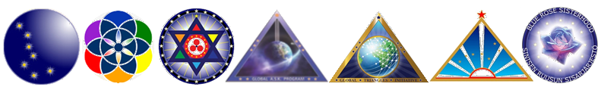
LUCIS TRUST TRIANGLES: A Planetary Network of Light and Goodwill
https://www.lucistrust.org/triangles
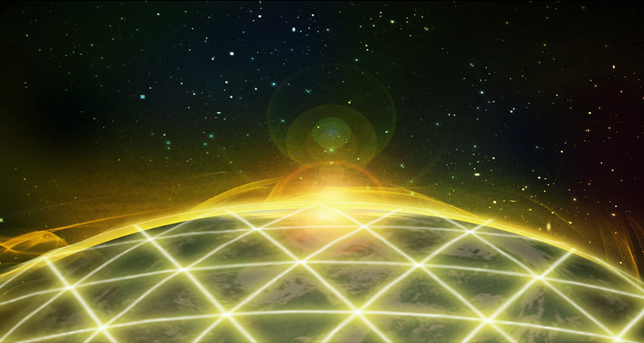

Service Through the Power of Thought
Triangles is a service activity, using the power of thought and of prayer to uplift and transform consciousness.
Three People Form a Triangle
Three people agree to link in thought each day. Using the Great Invocation, a world prayer, they visualize energies of light and goodwill circulating through the three focal points of their triangle, and pouring out through the network of triangles surrounding the planet. Participants imagine the hearts and minds of the human family being irradiated with light and goodwill, strengthening all that is good and true and of beauty in the world.
All Faiths and Spiritual Traditions
People of goodwill from all faiths and spiritual traditions are actively working with this daily rhythm. It is a brief practice that can easily be added to one’s regular period of prayer or meditation.
An Invitation
We invite you to join with two like-minded friends to add a new triangle to this planetary network of light and goodwill. You can also form a triangle online, finding others who are seeking Triangles partners.
Registration
If you would like to register your triangle you will receive a free quarterly Bulletin and further introductory material.

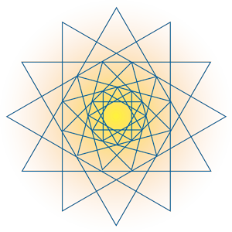
Triangles weekly webinars from Lucis Trust
https://www.lucistrust.org/triangles/webinar

Purpose of Triangles
https://www.lucistrust.org/triangles/about_triangles
Triangles links men and women of goodwill in a planetary service that transcends all barriers of race, creed, class, economic and political conviction. A worldwide network of light and goodwill is created for the distribution of spiritual energies. Triangles:
- Encourages men and women of goodwill to form triangles and assists them by explaining the work to be done.
- Publishes a Bulletin which is sent to all members and other interested men and women of goodwill.
- Issues educational material supporting the principles of Triangles and offers a weekly Webinar for Triangles workers and those who want to find out more about the network.
- Stimulates the formation of units of service in which men and women of goodwill can join together in practical world service.
- Helps to organise an annual world day of invocation, known as World Invocation Day.
- Supports initiatives to help widen the Triangles Network through the Triangles Meditation Group Facebook site; the Sharing Group Thought web page; the Global Network listing of units of service and Notes From the Field of Service web page.

How Triangles Work
There is increasing recognition of the power of meditation and visualisation. This power can be employed on a global scale for spiritual purposes if we try to understand the spiritual needs of the world and the contribution we can make as a worldwide group.
A triangle is a group of three people who link each day in thought for a few minutes of creative meditation. Triangles members need not necessarily live in the same locality, and many international triangles exist.
Each day members sit quietly for a few minutes and link mentally with other members of their triangle, or triangles. They invoke the energies of light and goodwill, visualising these energies as circulating throughout the three focal points of each triangle, and pouring out through the network of triangles surrounding the planet. At the same time they repeat the Great Invocation, so helping to form a channel for the downpouring of light and love into the consciousness of humanity.
The work takes only a few minutes each day and can fit into even the most crowded schedule. It is not necessary for members to synchronise the time at which the work is done, as once a triangle is built and functioning, it can be vitalised by any one of its members at any time of the day.
We welcome the contribution of all men and women of goodwill who are willing to do the work outlined above and accept the world service objectives of Triangles. There are no other requirements for membership. The financial needs of the work are provided solely and entirely by gifts of members and friends.

The Great Invocation
The Great Invocation is a world prayer translated into over eighty languages and dialects.
The Great Invocation
From the point of Light within the Mind of God
Let light stream forth into the minds of men.
Let Light descend on Earth.
From the point of Love within the Heart of God
Let love stream forth into the hearts of men.
May Christ return to Earth.
From the centre where the Will of God is known
Let purpose guide the little wills of men –
The purpose which the Masters know and serve.
From the centre which we call the race of men
Let the Plan of Love and Light work out
And may it seal the door where evil dwells.
Let Light and Love and Power restore the Plan on Earth.

The Great Invocation
Adapted
From the point of Light within the Mind of God
Let light stream forth into human minds.
Let Light descend on Earth.
From the point of Love within the Heart of God
Let love stream forth into human hearts.
May the Coming One return to Earth.
From the centre where the Will of God is known
Let purpose guide all little human wills –
The purpose which the Masters know and serve.
From the centre which we call the human race
Let the Plan of Love and Light work out
And may it seal the door where evil dwells.
Let Light and Love and Power restore the Plan on Earth.

Promoting Triangles in other languages
https://www.lucistrust.org/triangles/other_languages

